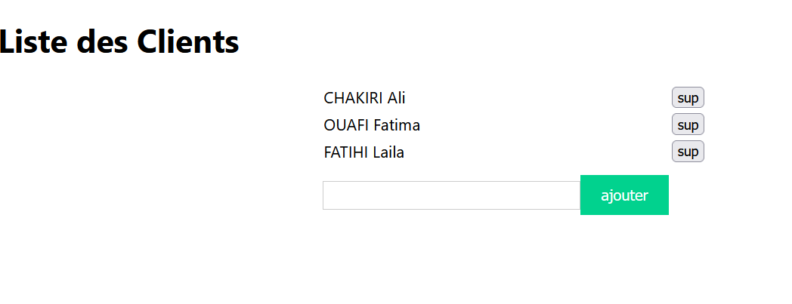

import React, { useState } from "react";

import ReactDOM, { createRoot } from 'react-dom/client';

import App from './App';

import reportWebVitals from './reportWebVitals';

import './index.css';

class MyNoms extends React.Component{

    state={clients:[{id: 1,nom:"CHAKIRI Ali"},{id: 2,nom:"OUAFI Fatima"},{id: 3,nom:"FATIHI Laila"}],nomclient:'',id:4};

  supprimerclick=(id)=>{

    const clients2= [...this.state.clients]

    const index=clients2.findIndex(client=>(client.id===id))

clients2.splice(index,1)

this.setState({clients : clients2});

  };

 ajoutclick=(e)=>{

e.preventDefault();

 const clients2= [...this.state.clients]

  clients2.push({id:this.state.id,nom:this.state.nomclient})

    this.setState({clients : clients2});

   this.setState({clients:clients2,nomclient:"",id:this.state.id+1});

console.log(this.state.id);

  };

    render(){

        const titre="Liste des Clients"

    // const  listeClients= this.state.clients.map(function(client){return <li>{client.nom}</li>})

     const  listeClients=  this.state.clients.map(client=>(<tr><td>{client.nom} </td><td><button onClick={()=>this.supprimerclick(client.id)}>sup</button></td></tr>))

    return ( <div><h1 >{titre}</h1>

   <form onSubmit={this.ajoutclick}>

   <table align="center">{listeClients}

   <input type ="text" value={this.state.nomclient} onChange={(e)=>{this.setState({nomclient:e.target.value})}}></input>

   <input type="submit" value="ajouter" /></table>

   </form>

    </div>);

    }

}

const root = ReactDOM.createRoot(document.getElementById('root'));

root.render(<MyNoms/>)

//root.render(<p>Hallo {age}{message()}</p>);

// If you want to start measuring performance in your app, pass a function

// to log results (for example: reportWebVitals(console.log))

// or send to an analytics endpoint. Learn more: https://bit.ly/CRA-vitals

reportWebVitals();

tp 2

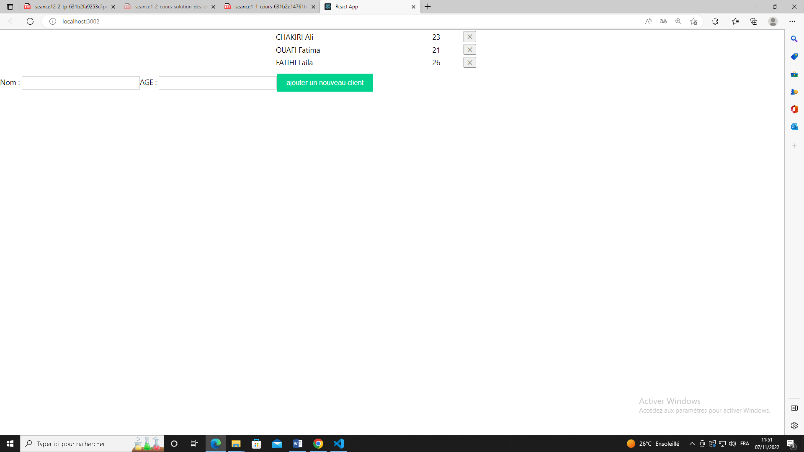

import React from "react";

import ReactDOM, { createRoot } from 'react-dom/client';

import reportWebVitals from './reportWebVitals';

import './index.css';

class Formclient extends React.Component{

  state={clients:[{id:1,nom:"CHAKIRI Ali",age:23},{id:2,nom:"OUAFI Fatima",age:21},{id:3,nom:"FATIHI Laila",age:26}],nomclient:'',id:2,ageclient:null}

  ajouterclient=(e)=>{

e.preventDefault();

const clients2=[...this.state.clients];

clients2.push({id:this.state.id+1,nom:this.state.nomclient,age:this.state.ageclient})

this.setState({clients:clients2})

this.setState({nomclient:''})

this.setState({ageclient:''})

  }

  supprimerclient=(id)=>{

    const index=this.state.clients.findIndex(client=>( client.id===id))

    console.log(index);

    const clients=[...this.state.clients];

clients.splice(index,1)

this.setState({clients:clients})

  }

  render(){

const listeClient=this.state.clients.map(client=>( <tr><td>{client.nom}</td><td>{client.age}</td><td><button onClick={()=>{this.supprimerclient(client.id)}} > &#10005;  </button></td></tr>))

  return (

<div>

  <form onSubmit={this.ajouterclient}>

<table align="center" width="30%">{listeClient}</table>

Nom : <input type="text" value={this.state.nomclient} onChange={(e)=>{ this.setState({nomclient:e.target.value})}}></input>

AGE  : <input type="text" value={this.state.ageclient} onChange={(e)=>{ this.setState({ageclient:e.target.value})}}></input>

<input type="submit" value="ajouter un nouveau client"></input>

</form>

</div>

  );

}

}

const root = ReactDOM.createRoot(document.getElementById('root'));

root.render(

    <Formclient/>

);

// If you want to start measuring performance in your app, pass a function

// to log results (for example: reportWebVitals(console.log))

// or send to an analytics endpoint. Learn more: https://bit.ly/CRA-vitals

reportWebVitals();